DECAM
Heater Controller Crate

User Manual

By Mark Kozlovsky

September 29, 2011

Table of Contents

1. Introduction 3
Fig. 1 Heater Crate Position in the Vessel (by Dave Huffman) 4
Fig. 2 Single Heater’s Control Configuration Diagram 5
2. Heater Controller Crate Specification 6
3. Heater Controller Crate Construction 7
Fig. 3 Pairing of the Heater Driver Board and the Heater Driver Transition Board (by Dave Huffman) 8
Fig. 4 Pairing of the Heater Patch Panel Board and the Heater Patch Panel Transition Board (by Dave Huffman) 9
Fig. 5 Front Panel of the Heater Driver Board 10
Fig. 6 Front Panel of the Heater Driver Transition Board 11
Fig. 7 Front Panel of the Heater Patch Panel Board 12
Fig. 8 Front Panel of the Heater Patch Panel Transition Board 13
Table 1 Pinout for the CONTROL connector 14
Fig.9 Heater Input Cable Assembly Diagram (by Steve Chappa) 15
Table 2 Pinout for the HEATERS connector 16
Fig.10 Heater Output Cable Assembly Diagram (by Steve Chappa) 17
Table 3 Pinout for TELEMETRY connector 18
Fig. 11a External Cable Connections 19
Fig. 11b External Cable Connections 20
4. Heater Driver 22
Fig. 12 Heater Driver Schematic 23
5. Testing the Heater Controller Crate 22

Introduction

Heater Controller Crate is capable of delivering currents to 12 heaters with internal resistance of 25 Ohms each. A single heater requires up to 0.8 Amps of current or 20V across it in order to contribute enough heat to the overall heat production as to keep telescope focal plane within the required temperature range. Construction of the Heater Crate is similar to that of an Acquisition (Data) Crate but employs different set of VICOR power supplies. Position of the Heater Controller Crate in the vessel is shown in Fig. 1.
A heater is driven by a differential driver which is controlled by single-ended input signal of up to 10V supplied by a NI-based Slow Control System. Differential output ensures exact gain of 2 thus providing maximum of 20V across the heater. Driver’s output voltage is prevented from exceeding 24V by employing transient voltage suppressors (TVS) with clamp-out voltage of 12V on both sides, negative and positive, of the driver. The latter is also protected from overheating by having its maximum output current set at 1.2A. If overheating occurs nevertheless, the driver shuts itself down automatically and the warning signal is provided via telemetry feedback to the Slow Control System.
Diagram in Fig. 2 shows all the system components involved in controlling of a single heater together with cables and ground connections.
As the very core of the Heater Crate’s design was to prevent heaters from introducing any additional noise into CCD readings, various solutions were implemented towards achieving that goal including but not limited to:
- Utilizing differential drivers to supply current to the heaters
- Heavily filtering input and output signals
- Using isolation amplifiers to interface with the Slow Control System
- Employing separate sets of power supplies for input and output control circuitries of the Heater Controller electronics
- Carefully designing grounding scheme in order to avoid any potentially hazardous ground loops
Extensive testing has proved effectiveness of those measures.
Control voltage is filtered from an induced noise by a 500 kHz low-pass filter and transferred to the differential amplifier whose outputs power the heater. Same outputs are returned as telemetry signals back to the NI-based Control System. To fully isolate heater currents from flowing into and from the external systems both control and telemetry signals are buffered by isolation amplifiers. To ensure even deeper isolation of the heater controller from the outside systems, it is powered by two separate and isolated power supplies, one of which has a common current return pass with the NI-based Control System and the other serves to power only internal electronics for the heaters. The ground reference point is the crate common point which in turn is connected to the vessel star common ground point usually referred as Earth Ground.

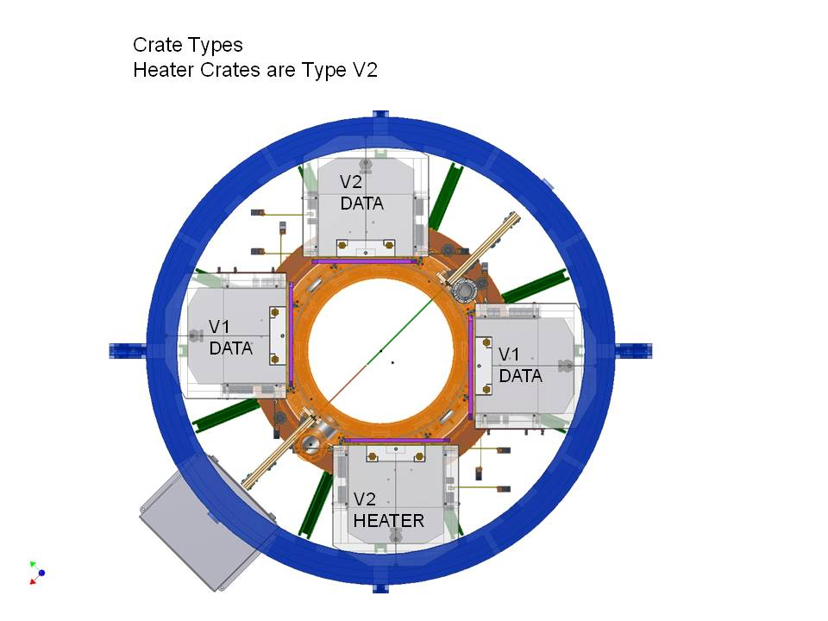

Fig. 1 Heater Crate Position in the Vessel (by Dave Huffman)

Fig. 2 Single Heater’s Control Configuration Diagram

Heater Controller Crate Specification

The following are design specifications for the Heater Controller Crate:

- Heater resistance: 25 ohms.
- Maximum heater operating voltage: 20 VDC
- Maximum heater current: 0.8 amps
- Number of controlled heaters: twelve heaters
- DC power supply
- Output voltage must not exceed 40 volts
- Over current protection limited to 1.6 amp
- Noise not to exceed that of a Lakeshore Controller #332
    - Loop 1: 50 µV + 0.017% of output voltage <1kHz RMS
    - Loop 2 <0.3 mV <1kHz RMS
- Input signal is from a NI cFP-AO-210 analog output module
- Signal is 0-10 VDC
- Maximum current 1 mA
- Signals are single-ended, all returns are common.
- Full manual at http://www.ni.com/pdf/manuals/323347a.pdf
- Status signals from Power Supplies and from control circuitry are read via Compact RIO/NI CompacDAQ, C Series Digital Output Module, NI 9401
- The input and status output signals must be isolated from the heaters.

Heater Controller Crate Construction

Heater Controller consists of 5 or 6 (depending on configuration) pairs of Heater Driver Boards and Heater Driver Transition Boards and 1 pair of Heater Patch Panel Board and Heater Patch Panel Transition Board. Their pairing is shown in Figures 3 and 4.

All input and output control signals are coming in to and going out of the drivers via connectors on the front panel on the Heater Patch Panel Board (see Figure 7). All interconnections between driver boards and between driver boards and an outside electronics are provided through connectors on front panels of the transition boards which are shown in Figures 6 and 8.

Each Heater Driver Board handles two heaters which are numbered 1 and 2 on the board but constitute a part of an overall array of heaters numbered from 1 to 10 (12). Correspondence between heaters and a particular driver board does not depend on a position of that board in the crate but is rather determined by a cable connection of that board to a particular connector on the front panel of the Heater Patch Panel Transition Board (Fig. 8). Thus for example, if any of the input connectors on the Heater Driver Transition Board (Fig. 6), all these connectors are wired in parallel, is connected to the output connector #3 on the Heater Patch Panel Transition Board, it means that corresponding Heater Driver Board handles heaters #5 and #6 from the heater array. In other words, Heater Patch Panel Transition Board’s output connectors handle the following heater in the vessel:

- Connector #1 - Heaters #1 and #2
- Connector #2 - Heaters #3 and #4
- Connector #3 - Heaters #5 and #6
- Connector #4 - Heaters #7 and #8
- Connector #5 - Heaters #9 and #10
- Connector #6 - Heaters #11 and #12

Fig. 3 Pairing of the Heater Driver Board and the Heater Driver Transition Board (by Dave Huffman)

Fig. 4 Pairing of the Heater Patch Panel Board and the Heater Patch Panel Transition Board (by Dave Huffman)

Fig. 5 Front Panel of the Heater Driver Board (by Dave Huffman)
Fig. 6 Front Panel of the Heater Driver Transition Board (by Dave Huffman)
Fig. 7 Front Panel of the Heater Patch Panel Board(by Dave Huffman)
Fig. 8 Front Panel of the Heater Patch Panel Transition Board (by Dave Huffman)

The Heater Patch Panel Board has two connectors on its front panel (Fig.5) called CONTROL and HEATERS.

The 25-pin AMP 747238-4 D-sub connector named CONTROL holds all input control signals coming from the NI-based Slow Control System. These signals are transferred to the crate via shielded input cable consisting of a number of individual shielded twisted pairs according to cable assembly diagram shown in Figure 9.

Pinout for the CONTROL connector is given in Table 1.

Table 1: Pinout for the CONTROL connector
Pin # | Signal Name | Signal Type | Signal Range | Comments
A1 | Shield 1 | GND
A2 | Input 1 | Analog | 0V … 12V | From 0V to 10V typical
A3 | Input 2 | Analog | 0V … 12V | From 0V to 10V typical
A4 | Shield 2/3 | GND
A5 | Input 3 | Analog | 0V … 12V | From 0V to 10V typical
A6 | Input 4 | Analog | 0V … 12V | From 0V to 10V typical
A7 | Shield 4/5 | GND
A8 | Input 5 | Analog | 0V … 12V | From 0V to 10V typical
A9 | Input 6 | Analog | 0V … 12V | From 0V to 10V typical
A10 | Shield 6/7 | GND
A11 | Input 7 | Analog | 0V … 12V | From 0V to 10V typical
A12 | Input 8 | Analog | 0V … 12V | From 0V to 10V typical
A13 | Shield 8 | GND
A14 | GND Control | GND
A15 | Shield 9 | GND
A16 | Input 9 | Analog | 0V … 12V | From 0V to 10V typical
A17 | Input 10 | Analog | 0V … 12V | From 0V to 10V typical
A18 | Shield 10/11 | GND
A19 | Input 11 | Analog | 0V … 12V | From 0V to 10V typical
A20 | Input 12 | Analog | 0V … 12V | From 0V to 10V typical
A21 | Shield 12 | GND
A22
A23
A24 | GND Control | GND
A25 | GND Control | GND

Fig.9 Heater Input Cable Assembly Diagram (by Steve Chappa)

The 50-pin AMP 747193-1 D-sub connector named HEATERS holds differential output control signals going to the heaters. Those signals travel to the heaters via a shielded cable with a number of shielded twisted pairs inside. Wiring of the pairs is done according to cable assembly diagram shown in Figure 10.

Pinout for the HEATERS connector is given in Table 2.

Table 2: Pinout for the HEATERS connector
Pin # | Signal Name | Signal Type | Pin # | Signal Name | Signal Type
A1 | Output 12+ | Analog 0V … 10V | A2 | Output 12- | Analog 0V … 10V
A3 | Shield | GND | A4 | Output 10+ | Analog 0V … 10V
A5 | Output 10- | Analog 0V … 10V | A6 | Shield | GND
A7 | Output 8+ | Analog 0V … 10V | A8 | Output 8- | Analog 0V … 10V
A9 | Shield | GND | A10 | Output 6+ | Analog 0V … 10V
A11 | Output 6- | Analog 0V … 10V | A12 | Shield | GND
A13 | Output 4+ | Analog 0V … 10V | A14 | Output 4- | Analog 0V … 10V
A15 | Shield | GND | A16 | Output 2+ | Analog 0V … 10V
A17 | Output 2- | Analog 0V … 10V | A18 | Shield | GND
A19 | Shield | GND | A20 | Shield | GND
A21 | Shield | GND | A22 | Shield | GND
A23 | Shield | GND | A24 | Shield | GND
A25 | Shield | GND | A26 | Shield | GND
A27 | Shield | GND | A28 | Shield | GND
A29 | Shield | GND | A30 | Shield | GND
A31 | Shield | GND | A32 | Shield | GND
A33 | Shield | GND | A34 | Output 11+ | Analog 0V … 10V
A35 | Output 11- | Analog 0V … 10V | A36 | Shield | GND
A37 | Output 9+ | Analog 0V … 10V | A38 | Output 9- | Analog 0V … 10V
A39 | Shield | GND | A40 | Output 7+ | Analog 0V … 10V
A41 | Output 7- | Analog 0V … 10V | A42 | Shield | GND
A43 | Output 5+ | Analog 0V … 10V | A44 | Output 5- | Analog 0V … 10V
A45 | Shield | GND | A46 | Output 3+ | Analog 0V … 10V
A47 | Output 3- | Analog 0V … 10V | A48 | Shield | GND
A49 | Output 1+ | Analog 0V … 10V | A50 | Output 1- | Analog 0V … 10V

Fig.10 Heater Output Cable Assembly Diagram (by Steve Chappa)

Input and output control signals are rewired on the Heater Patch Panel Board to the output connectors numbered 1 through 6 resided on the Heater Patch Panel Transition Board. They are then connected by cables to the corresponding input connectors on the Heater Driver Transition Boards. To provide the most convenient way of connecting cables each Heater Driver Transition Board is equipped with six input connectors wired in parallel and having the same physical locations as output connectors on the Heater Patch panel Transition Board. A suggested configuration of external cable connections to the Heater Controller Crate is shown in Figures 11a and 11b in which Figure 11a shows cable configuration for all the control signals, and Figure 11b shows telemetry cables and a cable configuration for the Shut Down signal.

Telemetry signals are provided by the Heater Driver Boards via telemetry connectors on their front panels (see Figure 5). Each telemetry connector provides telemetry signals from two heater drivers resided on this particular driver board. Correspondence between telemetry signals and a particular heater depends on the heater assignments for that driver board. For example, if this particular driver board is connected to the output connector # 3 on the Heater Patch Panel Transition Board, then telemetry signals from the Driver # 1 on this board relate to the Heater # 5, and telemetry signals from the Driver # 2 - to the Heater # 6, etc. Pinout for a telemetry 15-pin AMP 745782-4 connector is given in Table 3 below.

Table 3. Pinout for TELEMETRY connector
Pin # | Signal Name | Signal Type | Signal Range | Comments
A1 | Input Test 1 | Analog | ± 10V | Io ≤ 1.2A
A2 | Out Test1 + | Analog | ± 10V | Io ≤ 1.2A
A3 | Out Test1 - | Analog | ± 10V | Io ≤ 1.2A
A4 | Input Test 2 | Analog | ± 10V | Io ≤ 1.2A
A5 | Out Test2 + | Analog | ± 10V | Io ≤ 1.2A
A6 | Out Test2 - | Analog | ± 10V | Io ≤ 1.2A
A7 | GND Control
A8 | GND Control
A9 | Overheat1 + | Analog | 0.4V or 15V | Lower value means overheating
A10 | Overheat1 - | Analog | 0.4V or 15V | Lower value means overheating
A11 | Overheat2 + | Analog | 0.4V or 15V | Lower value means overheating
A12 | Overheat2 - | Analog | 0.4V or 15V | Lower value means overheating
A13 | GND Control
A14 | GND Control
A15 | GND Control

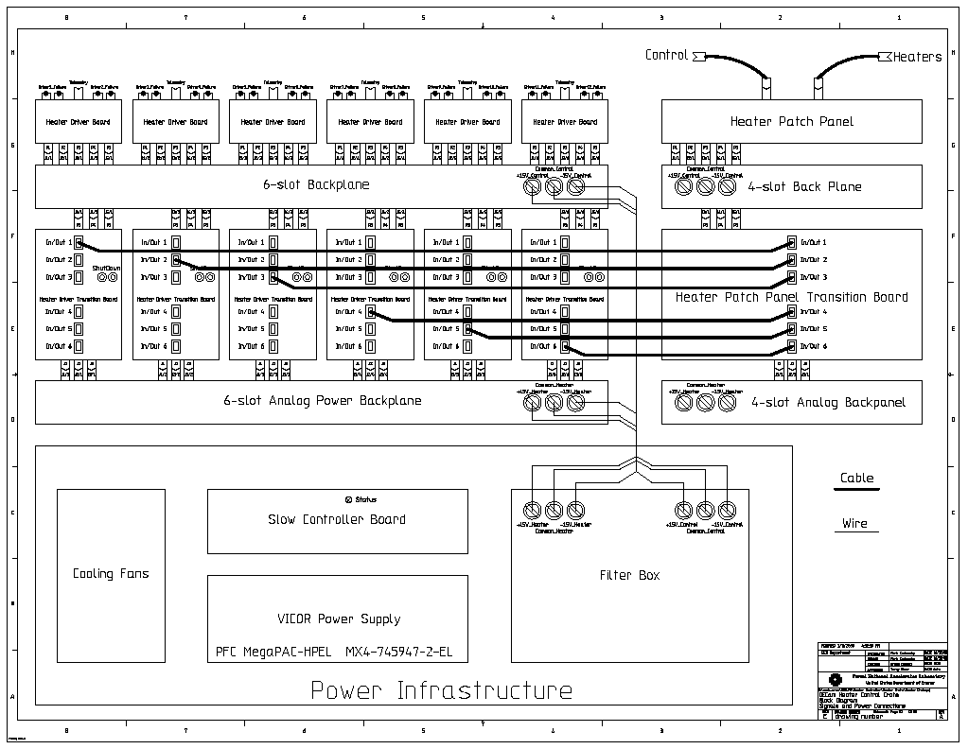

Fig. 11a External Cable Connections

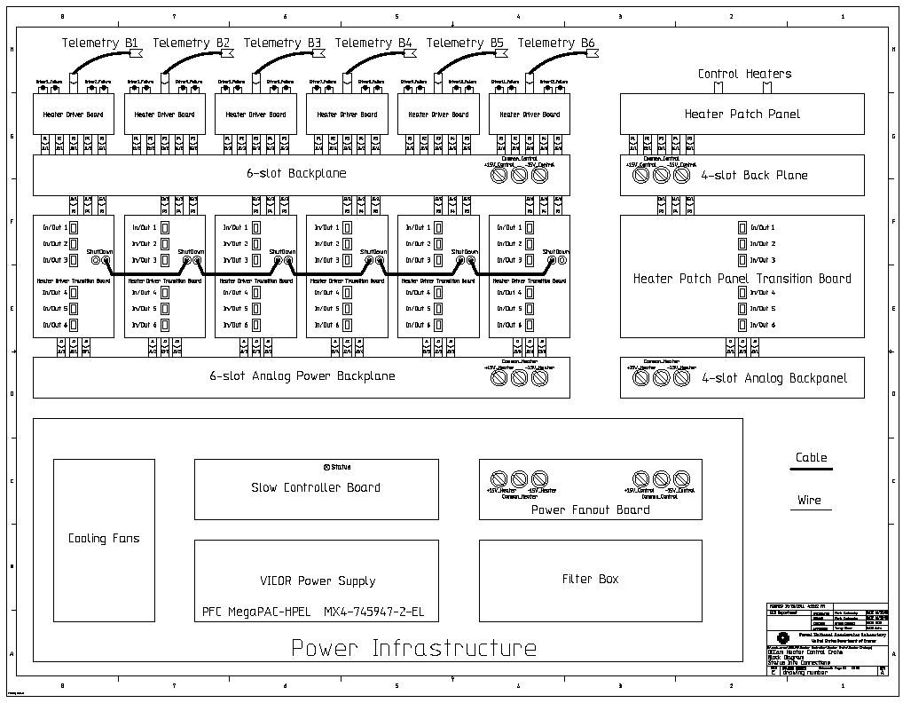

Fig. 11b External Cable Connections

Input Test telemetry signals reflect input signals from the Slow Control System and will have the same value as the latter.

Out Test telemetry signals correspond to the differential signals of opposite polarity supplied to the heaters and will have the same values as the input signals but with correspondent polarity. Differential voltage between + and – Out Test signals of the same number will be twice as big as the correspondent input voltage.

Overheat telemetry signals indicate a state when temperature inside individual driver chips (there are two of them for each heater driver) reached a dangerous level of 160°C. Steps for shutting down power supplies by the crate’s slow control system have to be taken to reduce the temperature in order not to damage the chips although chips will cycle themselves from shutdown to normal modes continuously in order to hold the temperature down thus preventing the damage. This may result in oscillation of the telemetry overheat signals.

Which particular driver chip in the heater deferential driver is overheating is determined by the name of the signal. Thus, signal named “Overheat1 +” indicates that chip responsible for the positive output of the first differential drive is overheating, and otherwise signal named “Overheat1 -” indicates that chip responsible for the negative output of the first differential drive is overheating, etc.

Statuses of the overheat signals are also duplicated by failure LED indicators on the front panels of the Heater Driver Boards (see Figure 5). When any of those indicators is turned on then that means that the corresponding overheat signal is low which, in turn, indicates that corresponded to the latter chip is overheating. Accordingly, when the chip starts switching between shutdown and normal modes, the corresponding LED indicator starts flashing.

All telemetry input and output test signals are also provided on the front panels of the Heater Driver Boards via LEMO connectors which are marked accordingly (see Figure 5). Those are useful for board debugging and quick status checking.

One more monitored signal in the Heater Controller Crate is Shutdown which is organized as an OR-like circuitry by connecting together all Shutdown outputs on all the Heater Driver Transition Boards. This is shown in Figure 11b. The signal then is fed internally into the crate’s Slow Controller Board via the Analog Power Backplane. The signal represents statuses of all hot swap controllers resided on the Heater Driver Transition Boards. It is a TTL-compatible (from 0.4 to 4.5V) logic signal with low state being an indication of one of the hot swat controllers’ failure. When failure occurs, the Slow Controller Board will enter its shut down procedure eventually turning off all the crate power supplies. For convenience, each Heater Driver Transition Board is equipped with two SHUTDOWN connectors, which are wired together, so connection cables do not cross each other when attached.

Heater Driver

Heater driver is the main system component. Its schematic is shown in Figure 12. A heater driver consists of an isolation amplifier with gain of 1, a low pass 500KHz ripple filter, an inverter, a single ended to differential output power driver/amplifier with differential gain of 2, and signal monitor buffers.

The heater driver is configurable with all the possible configuration modes and corresponding configuration jumper settings shown on the schematic. The default mode is “Inversed Filtered Input”.

Input signal from the NI-based Slow Control System goes through the isolation amplifier and then passes through the filter and inverter to come to the input of the differential power driver. The latter consists of two OPA548 power amplifiers organized as a single ended to differential output amplifier with differential gain of 2. Amplifiers are heavily bypassed to avoid ripples on the load and are guarded to exceed 12V on its outputs. Besides that, the amplifiers are limited to 1.2 Amps of output current by connecting its Pins 3 and 4 via a 45.3K resistor and their internal temperature is monitored at the E/S outputs (Pin 7). The outputs of the amplifiers go directly to a heater and, through signal monitor buffers, are provided for reading to the NI-based Slow Control System.

Testing the Heater Controller Crate

Note of caution: this section cannot be construed as an instruction for either system or board troubleshooting or debugging manual! Its purpose is to describe procedures for field testing and checking proper functionality of the crate.

Considering a fully assembled and configured heater crate controller, the testing of it in the field is pretty simple. It can be done either automatically by the NI-based Slow Control System or manually by using a standard off-the-shell sine wave generator and an oscilloscope.

Fig. 12 Heater Driver Schematic

For an automatic testing, the NI-based Slow Controller has to repeatedly ramp all the input heater control signals from 0V to 10V and back simultaneously reading all telemetry input and output test signals. The latter have to ramp from 0V to either 10V or -10V as well depending on their specified polarity. There will be a small difference in maximum voltages between input and output ramps which is explained by a voltage drop across multiple amplifiers and buffers for the test signals (this voltage drop has to be determined empirically and will differ from unit to unit) but the trend has to be the same: up and down from 0V.

If polarity of any of the test signals does not coincide with its specified polarity, then this channel’s configuration mode has to be changed in a way as to ensure the matching. If any of the test signals does not follow the ramp or has substantially lower maximum voltage on it, then this channel has to be troubleshoot for finding a cause for the problem.

For the manual testing, the heater input cable has to be disconnected from the NI-base Slow Control System. All input control signals on the unconnected end connector of the input cable have to be combined and connected to the output of the sine generator. The ground pins on the same connector have to be combined as well and connected to the common/ground terminal of the generator which, in turn, has to be connected to earth ground on the vessel. The generator has to be set to produce 1V, 1KHz sine wave.

The operator then checks individually all the input and output test signals on the front panels of the Heater Driver Boards with the oscilloscope. All those signals have to repeat the same sine wave albeit with different polarity depending on their assignments. Same as above for the automated testing, if any of the test signals does not follow the ramp or has substantially lower maximum voltage on it, then this channel has to be troubleshoot for finding a cause for the problem.

Second test for the crate is to check its SHUTDOWN chain. To do that, one has to touch with a ground central pin on any unused SHUTDOWN LEMO connector and hold it for a while. With that the crate power supplies have to be turned off by the Slow Controller Board. If this does not happen please refer to the Slow Controller Board’s manual in the DES document data base.

