Clock board test

The performance of the CB in a CCD DAQ system is critical since its yield affects deeply to charge transfer efficiency and low noise readout. Accuracy and precision in clock signals along with a proper clock waveform are the main requirements for the CB. The key difference of DES CB with respect to other boards with the same functionality is the high density of clock channels implemented in a small area. Thus, one clock board has up to 135 clock channels. Since the production set extends to 20 boards there are up to 2700 clock channels to test. A manual testing of such amount of clock channels becomes a very tedious and error prone task. Thus, the automation of the main part of the process was the primary approach in CB testing. This automation has required the design of some additional hardware as the CCD Emulator Board which allows us to emulate CCD load. Also a specific clock signal can be selected via parallel port from the CCD Emulator Board to be analyzed. In addition, a software application (CBtest) has been designed for verifying clock voltages and waveforms. CBtest communicates with different elements as the Monsoon software (MEC, pandaemon), the multimeter and the CCD Emulator Board to program and measure clock signals. The figure 1 shows a scheme of the main blocks of the test setup.

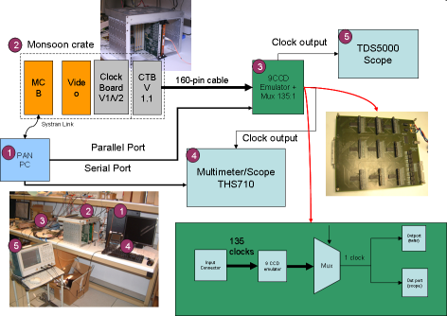
Figure 1. Clock board test setup

The configuration and test of the CB board is performed in several stages described in the following sections.

1. CB configuration

The CB requires some preliminary hardware and software configurations as plugging several jumpers and the load of the FPGA firmware through a JTAG connection. In addition, a power supplies checking is also performed. Figures 2 and 3 show the default jumper configuration settings and power supplies checking.
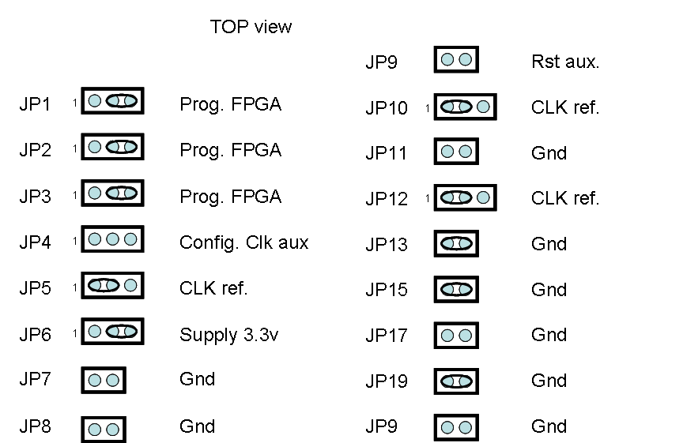

Figure 2. Jumpers settings

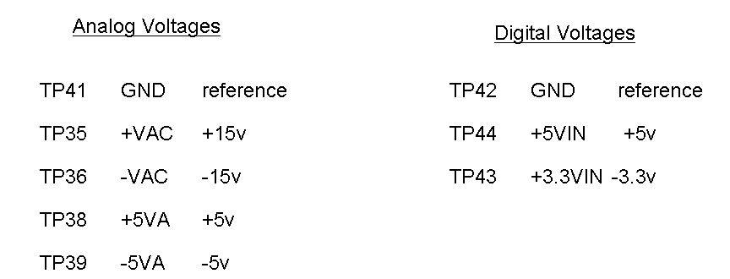
Figure 3. Power supply checking

2. Clock Channel Chain Test

The goals of Clock Channel Chain Test is to detect possible defective components, assembly faults, etc., to ensure ±10 voltage range for all clock channels and to produce the calibration file which stores the calibration constants.

The methodology to achieve these goals consists of several steps:

- Calibration-. Programming and measuring clock voltages to compute the calibration constants (coef1, coef2) for all clocks. The calibration constants are stored in a file. A simple visual inspection of the calibration file allows the user to prematurely detect anomalies in calibration constants due to assembly faults or defective components . Figure 4 shows the main software and hardware blocks implicated in CB calibration.

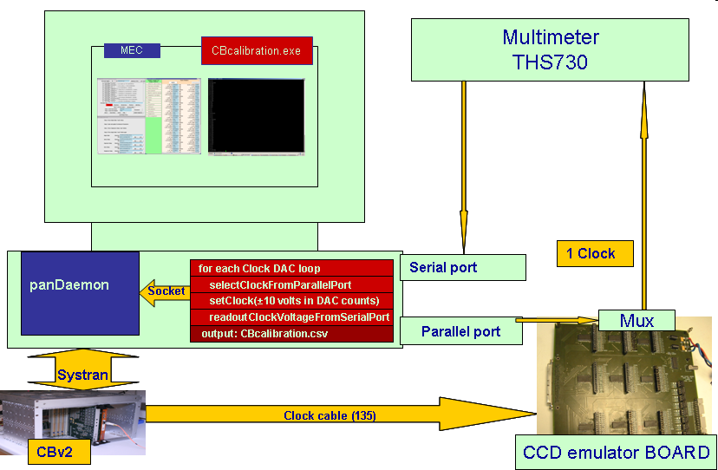

Figure 4. Hardware/Software main blocks for CB calibration.

- Configuration updating-. The calibration constants computed above are integrated into Monsoon configuration file (csv file). Later, a Monsoon software reinitialization should be performed to proceed with further measurements.

- Clock Channel Accuracy Test.- In this stage an histogram of the differences between programmed voltages and measured voltages is performed. There are some issues that affect directly to accuracy of voltage clocks as a DAC resolution of 95 mV (+10 to -10 volts within operational DAC range: 22 to 233 DAC counts), the multimeter resolution of 10 mV and the electronic tolerance of components. Fig. 5 shows the hardware/software configuration implemented for this test. To compute the accuracy, the CBhistogram routine sets sequentially the high and low DACs of each clock channel to 9 voltage points (±8,±6,±4,±2,0 volts). For each programmed voltage the CBhistogram routine selects via parallel port the corresponding clock in the CCD Emulator Board. Thus the clock signal is redirected to the multimeter from which the the CBhistogram routine performs the readout via serial port. Since there are 9 points per DAC, 2 DACs and 126 clocks (excluding 9 clocks corresponding to n+guard signals out of the global 135 clock channels), a total of 2268 clock voltages difference measurements are computed for the accuracy histogram. An RMS (root mean square) value is also computed and later used as acceptance criteria for the board.

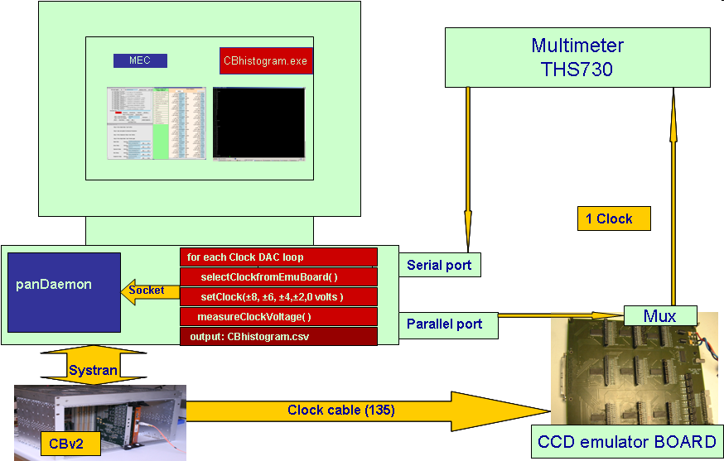
Figure 5. HW/SW configuration for accuracy test

As shown in Fig. 6, the results of this test provides an information about the existence of defective channels that can be easily identified later by the inspection of log files.

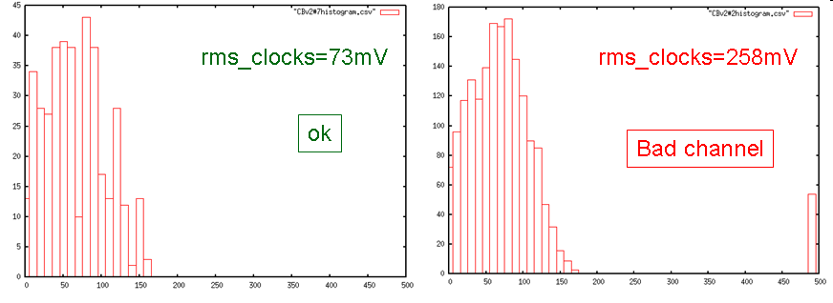

Figure 6. Clock channel accuracy histogram

3. Telemetry channel test

Nowadays, clock telemetry is an essential part of CCD controllers since allows the operator to verify in real time the proper behaviour of clock channel circuits. By means of this test it can be identified malfunctions of telemetry channel circuits. The setup for verifying telemetry channels is shown in Fig. 7.
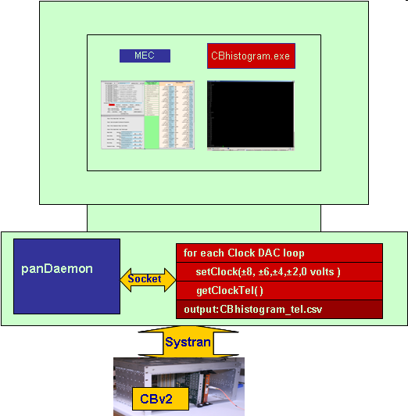
Figure 7. HW/SW configuration for telemetry test

The basic procedure consists of generating a histogram of the differences of programmed voltage and measured voltages with telemetry circuits. Fig. 8 shows the results of telemetry channel test. The detection of far counts arise the suspicion of malfunctioning in telemetry circuits that can be verified by further inspection of telemetry logs files. Also an acceptance criteria is established based on rms_tel (root mean square for telemetry) value.

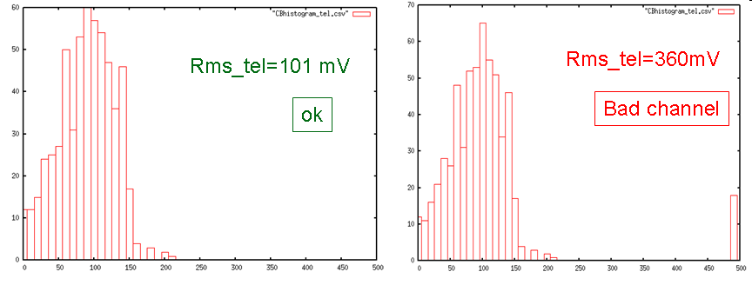

Figure 8. Telemetry histogram

4. Clock waveform visualization

Up to now, the test performed checks clocks channel levels. In the current test, the clock waveforms are visualized to detect possible anomalies while all clocks are running. The basic setup for this test is shown in Fig. 9. The MEC program is initialized in continuous mode (clocks running periodically) and the output of the multiplexer of the CCD emulator board is connected to the scope. ExploreSignals routine allows the user the selection of any clock out of 135. Clock waveforms are visualized sequentially at the scope. Different clock signal orders can be established (by name, by CCD, etc.) for convenience.

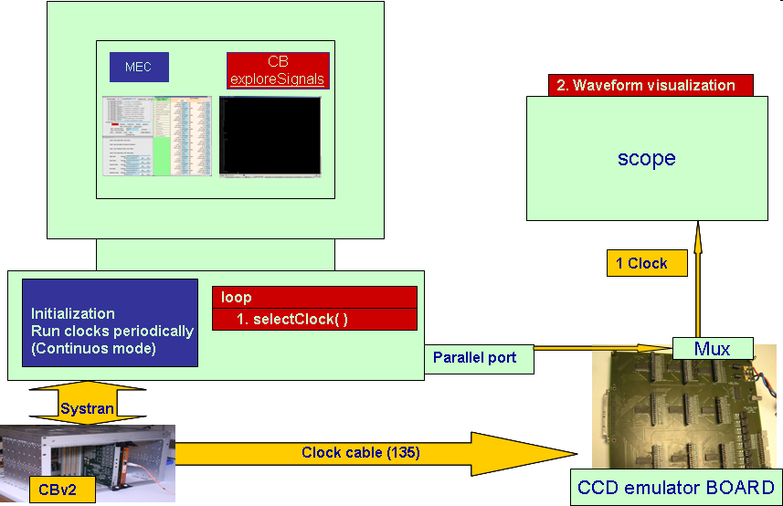
Figure 9. HW/SW configuration for clock waveform visualization

5. Front Panel Test

In addition to telemetry, the CB offers two front panel ports for visualizing clocks signals in real time. The outputs of these ports are controlled multiplexers. The correct behaviour of such multiplexers is verified by Front Panel Test. Fig. 10 shows the setup for this test. The basic procedure consists of programming the clocks with incremental voltage levels according to their order in the clock frame. Later, clocks are selected in order in the front panel and the small voltage jumps are verified with a multimeter or a scope.

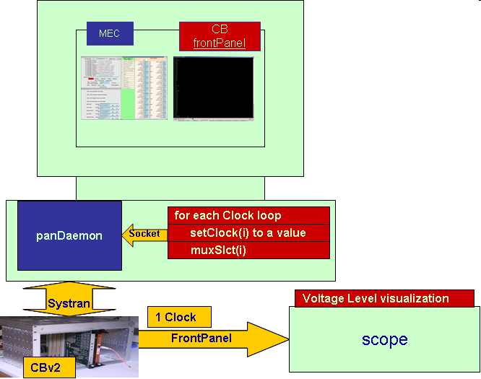
Figure 10. HW/SW configuration for front panel test

6. Documentation

A directory with the files generated in the tests is maintained for each board. In addition a data sheet per board is fulfilled with information about jumper setting, power supplies, firmware version loaded and relevant results provided by the tests. Figure 11 show an image of this data sheet.

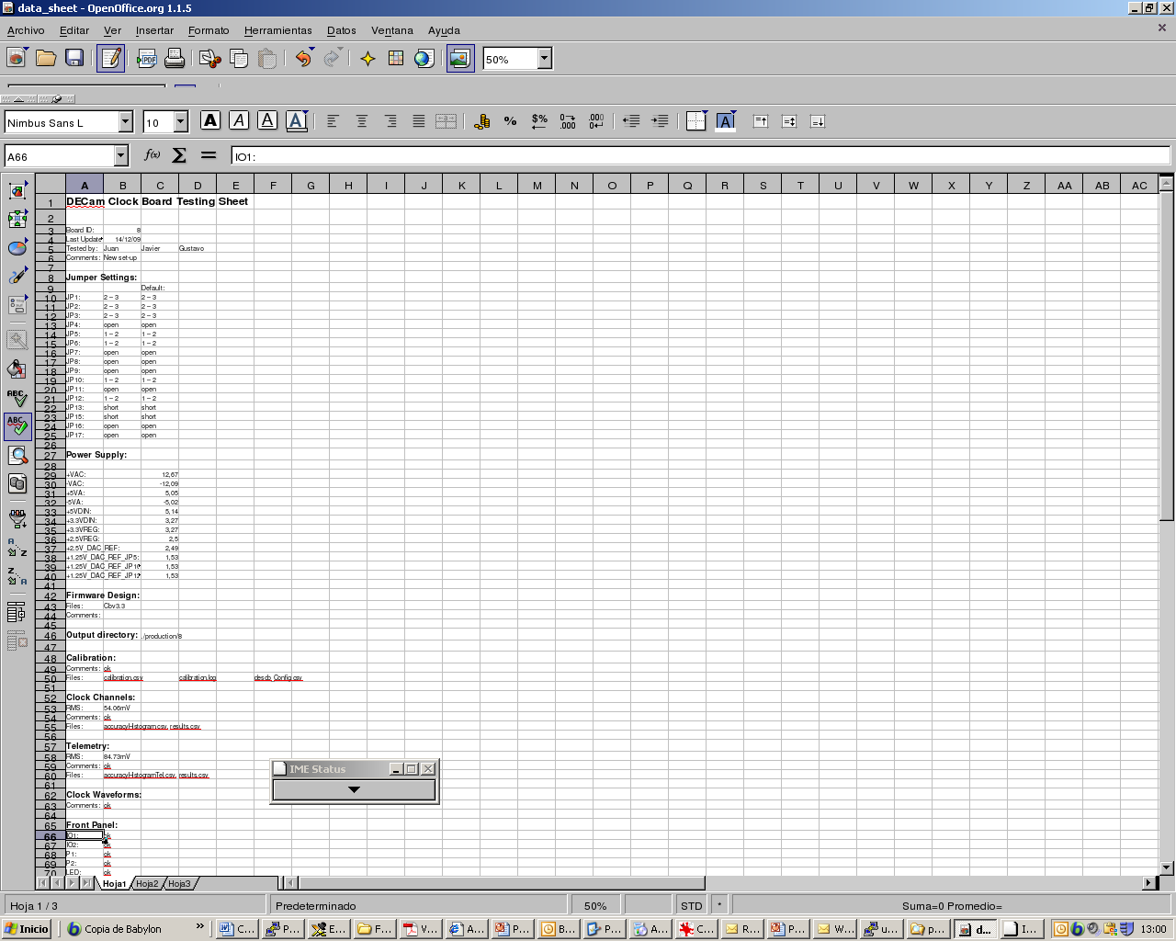

Figure 11. Data sheet with test results

